**דוח מעבדה 10**

**שמות מגישים:**

סער ויקטור – 312392822

אילון בן סימון – 312162951

**תרגיל 1**

קוד התכנית:  
header :

#ifndef example1

#define example1

#include <stdio.h>

#include <stdlib.h>

#include<conio.h>

//PSTACKNODE is pointer to struct (node)

typedef struct node *PSTACKNODE;

//Functions declaration

void push(void *, PSTACKNODE *stack);

void pop(PSTACKNODE * stack, void(*free_data)(void*));

int isempty(PSTACKNODE stack);

void* top(PSTACKNODE stack);

#endif // !example1

Main:

#include"example1.h"

//Define specific functions

//The function free char

void free_char(void *elem)

{

free(elem);

}

int main()

{

PSTACKNODE stack = NULL;

char key;

char *ch;

puts("Enter characters, separated by space. Press enter to stop\n");

do//A do while loop that scan characters until the user insert enter

{

ch = (char*)malloc(sizeof(char));//Creates a specific address for each variable that is scan from the user

key = getchar();

*ch = key;

_flushall();

push(ch, &stack);

} while (key != '\n');

puts("Here are the characters in reverse order:\n");

while (!isempty(stack))//A loop that prints data from a linked list as long as the list is not empty

{

printf(" %c ", *(char*)top(stack));

pop(&stack,free_char);

}

getch();

return 0;

}

Implementation:

#include"example1.h"

//Define general functions and structures

typedef struct node

{

void* data; /* Store the keystroke by the user */

struct node *next; /* Pointer to the next node */

} STACKNODE;

//The function creates a linked list

void push(void * key, PSTACKNODE *stack)

{

STACKNODE *newnode;

newnode = (STACKNODE *)malloc(sizeof(STACKNODE));

newnode->data = key;

newnode->next = (*stack);

(*stack) = newnode;

}

//The function return the data (void*) to the main

void * top(PSTACKNODE stack)

{

return stack->data;

}

//The function free node from linked list

void pop(PSTACKNODE * stack, void(*free_data)(void*))

{

STACKNODE *oldnode;

oldnode = (*stack);

(*stack) = (*stack)->next;

free_data(oldnode->data);

free(oldnode);

}

//The function check if the linked list is empty

int isempty(PSTACKNODE stack)

{

return (stack == NULL);

}

פלט:

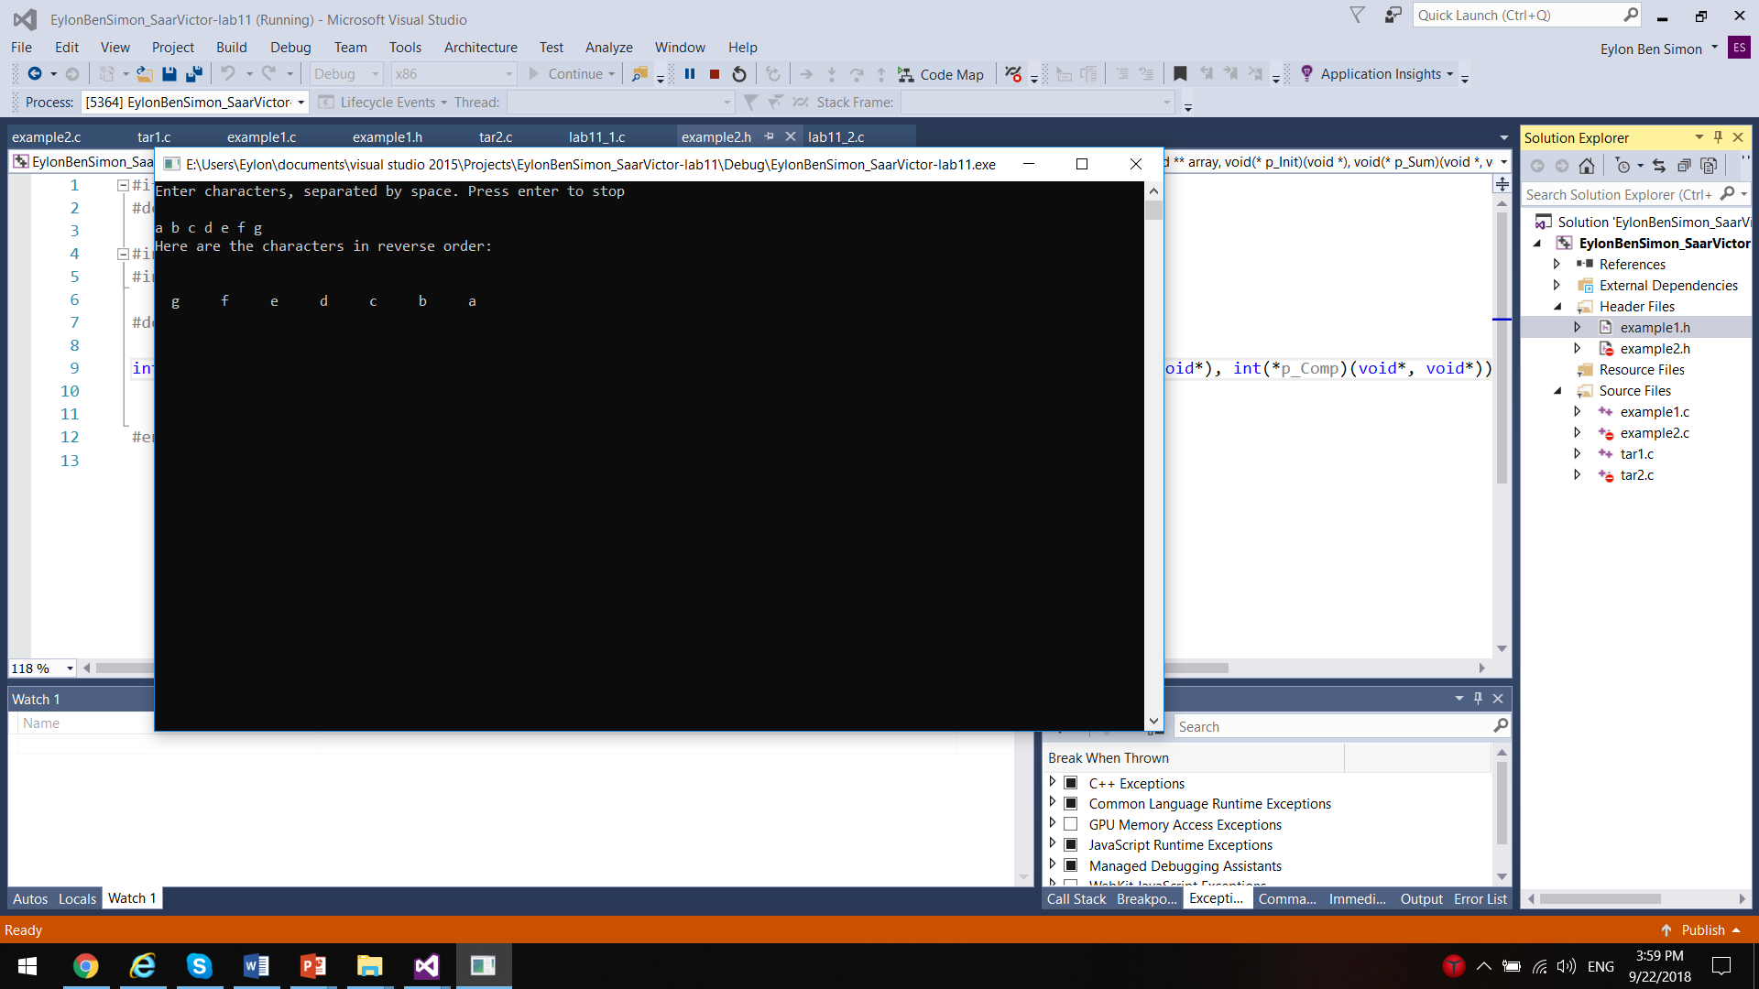

**תרגיל 2**

קוד התכנית:

header :

#ifndef example2

#define example2

#include<stdio.h>

#include<conio.h>

#define N 5

//Function declaration

int Do_It(void *sum, void** array, void(*p_Init)(void *), void(*p_Sum)(void*, void*), void(*p_Sub)(void*, void*), int(*p_Comp)(void*, void*));

#endif // !example2

Main:

#include"example2.h"

//Define specific functions

//The function compare between two numbers

int Int_Comp(void *a, void *b)

{

if (*(int*)a == *(int*)b)

return 1;

return 0;

}

//The function perform sum

void Int_Sum(void *sum, void *num)

{

*(int*)sum += *(int*)num;

}

//The function performs subtraction

void Int_Sub(void *sum, void *num)

{

*(int*)sum -= *(int*)num;

}

//The function initializes a number

void Init(void *p)

{

*(int*)p = 0;

}

int main()

{

int num[] = { 5,8,23,20,23 }, i, answer;

void *p_num[N];//Pointers array

for (i = 0; i < N; i++)

{

p_num[i] = &num[i];//Fill the pointers array

}

answer = Do_It(&answer, p_num, Init, Int_Sum, Int_Sub, Int_Comp);

if (answer == 1)

printf("The answer is 'Yes'");

else

printf("The answer is 'No'");

getch();

return 0;

}

Implementation:

#include"example2.h"

//Define general functions and structures

//A function that sum numbers in the even places and subtracts numbers in the odd places and checks if the next number in the array equals the result

int Do_It(void *sum, void** array, void(*p_Init)(void *), void(*p_Sum)(void*, void*), void(*p_Sub)(void*, void*), int(*p_Comp)(void*, void*))

{

int i;

p_Init(sum);//Initializing the variable sum

for (i = 0; i < N-1; i++)

{

if ((i+1) % 2 != 0)

p_Sum(sum, array[i]);

else

p_Sub(sum, array[i]);

if (p_Comp(sum, array[i + 1]))

return 1;

}

return 0;

}

פלט:

